**Introduction to Mathematical Finance**

**Problem Sheet 1 Answer**

1. LIBOR rates are determined:

**C** LIBOR rates are determined in the market for interbank lending.

2. A market rate of discount for a single payment to be made in the future is:

**A** A spot rate is a discount rate for a single future payment. Simple yield is a measure of a bond’s yield that accounts for coupon interest and assumes straight-line amortization of a discount or premium. A forward rate is an interest rate for a future period, such as a 3-month rate six months from today.

3. An analyst observes a 20-year, 8% option-free bond with semiannual coupons. The required yield-to-maturity on a semiannual bond basis was 8%, but suddenly it decreased to 7.25%. As a result, the price of this bond:

**A** The price-yield relationship is inverse. If the required yield decreases, the bond’s price will increase, and vice versa.

4. You are estimating a value for an infrequently traded bond with six years to maturity, an annual coupon of 7%, and a single-B credit rating. You obtain yields-to-maturity for more liquid bonds with the same credit rating:

5% coupon, eight years to maturity, yielding 7.20%.  
6.5% coupon, five years to maturity, yielding 6.40%.

The infrequently traded bond is most likely trading at:

**C** Using linear interpolation, the yield on a bond with six years to maturity should be 6.40% + (1 / 3)(7.20% – 6.40%) = 6.67%. A bond with a 7% coupon and a yield of 6.67% is at a premium to par value.

5. A floating-rate note has a quoted margin of +50 basis points and a required margin of +75 basis points. On its next reset date, the price of the note will be:

**B** If the required margin is greater than the quoted margin, the credit quality of the issue has decreased and the price on the reset date will be less than par value.

A. A 20-year, 10% annual-pay bond has a par value of $1,000. What is the price of the bond if it has a yield-to-maturity of 15%?

N = 20; I/Y = 15; FV = 1,000; PMT = 100; CPT → PV = **–$687.03.**

B. An analyst observes a 5-year, 10% semiannual-pay bond. The face amount is £1,000. The analyst believes that the yield-to-maturity on a semiannual bond basis should be 15%. Based on this yield estimate, the price of this bond would be:

N = 10; I/Y = 7.5; FV = 1,000; PMT = 50; CPT → PV = **–$828.40.**

C. A $1,000, 5%, 20-year annual-pay bond has a YTM of 6.5%. If the YTM remains unchanged, how much will the bond value increase over the next three years?

With 20 years to maturity, the value of the bond with an annual-pay yield of 6.5% is N = 20, PMT = 50, FV = 1,000, I/Y = 6.5, CPT → PV = –834.72. With N 17, CPT → PV = –848.34, so the value will increase **$13.62.**

D. If spot rates are 3.2% for one year, 3.4% for two years, and 3.5% for three years, the price of a $100,000 face value, 3-year, annual-pay bond with a coupon rate of 4% is closest to:

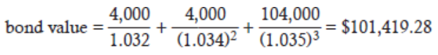

E. An investor paid a full price of $1,059.04 each for 100 bonds. The purchase was between coupon dates, and accrued interest was $23.54 per bond. What is each bond’s flat price?

The full price includes accrued interest, while the flat price does not. Therefore, the flat (or clean) price is 1,059.04 – 23.54 = **$1,035.50.**

F. Based on semiannual compounding, what would the YTM be on a 15-year, zero-coupon, $1,000 par value bond that’s currently trading at $331.40?

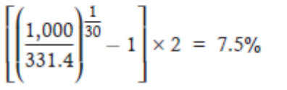

G. An analyst observes a Widget & Co. 7.125%, 4-year, semiannual-pay bond trading at 102.347% of par (where par is $1,000). The bond is callable at 101 in two years. What is the bond’s yield-to-call?

N = 4; FV = 1,010; PMT = 35.625; PV = –1,023.47; CPT → I/Y = 3.167 × 2 = **6.334%.**

H. The 4-year spot rate is 9.45%, and the 3-year spot rate is 9.85%. What is the 1-year forward rate three years from today?

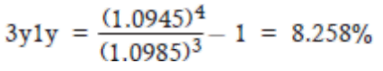

Approximate forward rate = 4(9.45%) – 3(9.85%) = **8.25%.**

I. Given the following spot and forward rates:  
Current 1-year spot rate is 5.5%.  
One-year forward rate one year from today is 7.63%.  
One-year forward rate two years from today is 12.18%.  
One-year forward rate three years from today is 15.5%.  
The value of a 4-year, 10% annual-pay, $1,000 par value bond is closest to:

